Psychophysics Software Suite (PSS)
User Manual
Table of Contents
1 Requirements 2
2 Launching the Psychophysics Software Suite (PSS) 2
3 Test Tool: Building the PSS Test 4
The menu options: 4
The buttons options: 5
Block Options 6
4 Sound Types and Parameters 8
a. Pure Sound 8
b. Accord Sound 9
c. Noise Sound 10
d. Modulated Sound 11
e. Gap Sound 12
5 Run Tool: Executing the PSS Test 13
6 Analysis Tool: Displaying the PSS Test results 15

Requirements
- PC with a user pointing device such as computer mouse or a touch screen
- Display capable of 800x600 resolution
- Sound Card capable of playing 44.1 Hz 16 bit sound
- MathWorks Matlab version 7.7 (R 2008b) and newer. Older version may not work due to lack of full OOP support.

Launching the Psychophysics Software Suite (PSS)
Before lunching PSS make sure the PSS path is defined in Matlab path. Use Matlab command prompt ‘path’ command to check it out. Run the PSS by entering ‘tools’ in Matlab command prompt.
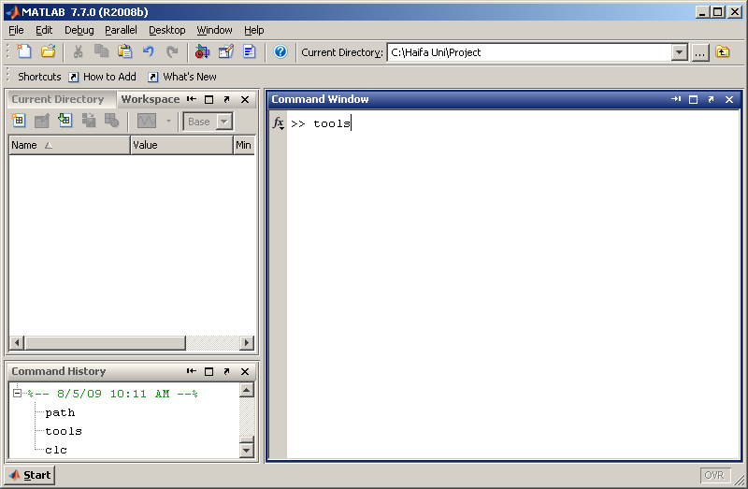

The following PSS window should appear:
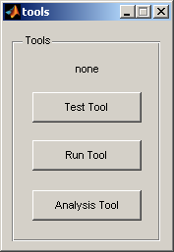
Test Tool – the utility used to create PSS tests, to define test parameters and to save the test as a .test file
Run Tool – the utility used to start PSS test execution and save the data
Analysis Tool – the utility used to display the PSS test results and to provide tools for basic PSS test analysis.

Test Tool: Building the PSS Test
Pressing Test Tool button will launch PSS Test building tool:
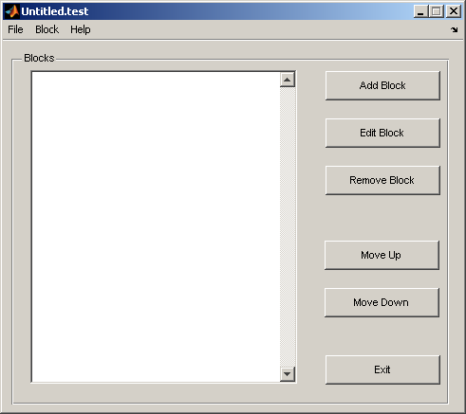

The menu options:
File -> New creates a new PSS Test
File -> Open opens a saved copy of PSS Test
File -> Save saves a current PSS Test as a file
File -> Exit closes the PSS Test building Tool
Block -> Add Block adds a block to the current PSS Test
Block -> Edit Block enables the user to edit the parameters of the selected block
Block -> Remove Block removes the selected block from the current PSS Test
Help -> About launches the about box

The buttons options:
Add Block adds a block to the current PSS Test
Block enables the user to edit the parameters of the selected block
Remove Block removes the selected block from the current PSS Test
Move Up moves the selected block one position up
Move Down moves the selected block one position down
Exit closes the PSS Test building Tool

Block Options
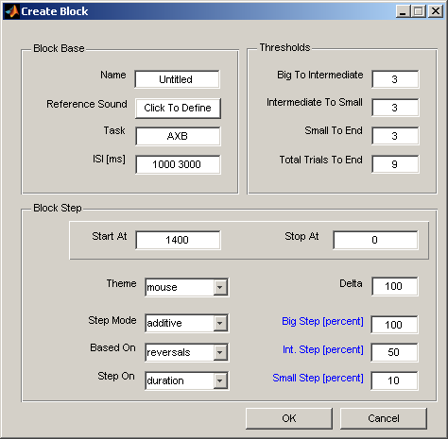

General Block Options:
Name – the name of the block (should be unique within the test).
Reference Sound – click on this button to define the reference sound for the given block
Task – defines the form of the block’s task (should include at least one A, B, X letter, where A/B represent reference or modified sound (chosen in random fashion), X is always a reference sound)
ISI [ms] – Inter Stimulus Interval (the time in milliseconds between two consecutive stimuli within one trial. To define ISI within some time range you may specify two numbers [t1 t2], so in Test runtime ISI will be picked as some time t such as t1<t<t2
Start At – specifies the starting value of the non-reference sound modified parameter
Stop At – defines the value of the reference sound modified parameter which cannot be exceeded during the test run. Leave a zero at this field if you’re not interested to bound modified parameter
Theme – defines the theme of the current block
Step Mode – the mode of parameter change, it may be either additive or multiplicative.
In the case of additive mode, when its time to change the value of the adaptive parameter (usually after 3 consecutive correct answers) – the current adaptive parameter value is reduced by delta amount, otherwise the value is increased by Delta. Please pay attention that in this mode Delta parameter should be positive in order to be consistent with PSS requirements.
In mulplicative mode each time the users reply is correct – the difference between the current value and a reference sound is divided by Delta amount, in the case that reply was incorrect the difference is increased by multiplying by Delta. Please pay attention that in this mode Delta parameter should be greater than one in order to be consistent with PSS requirements. (Note: in published work using this method, delta is usually 2, 1.41 and 1.25 for the big, int., and small steps respectively)
Based On – sets the events (reversals, trials) that thresholds will depend on.
In the case of trials mode the thresholds will be triggered by exceeding some number of trials.
In reversals mode only a direction change (from increasing value to decreasing or vice versa) will be counted as event capable to trigger a threshold.
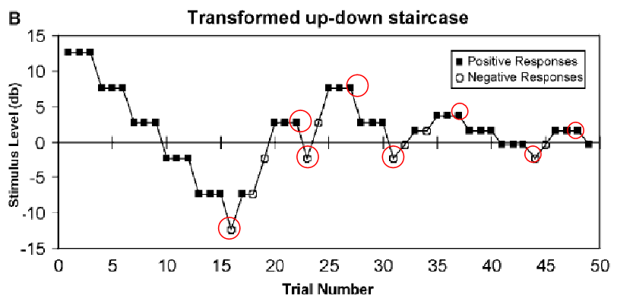
Step On – defines the adaptive parameter (e.g. frequency, intensity) for the current block.
Delta – the value that determinates the amount by which the adaptive parameter changes when a change is due.
Big Step [percent] – defines the value of delta for big steps in percents from Delta. To define this value by absolute value – right click on the blue text.
Int. Step [percent] – defines the value of delta for intermediate steps in percents from Delta. To define this value by absolute value – right click on the blue text.
Small Step [percent] – defines the value of delta for small steps in percents from Delta. To define this value by absolute value – right click on the blue text.

Thresholds Options
Big To Intermediate – sets the number on events (trials or reversals, depends on Based On mode) to trigger a switch from big steps to intermediate ones.
Intermediate To Small – sets the number on events (trials or reversals, depends on Based On mode) to trigger a switch from intermediate steps to small ones.
Small To End – sets the number on events (trials or reversals, depends on Based On mode) to trigger a switch from small steps end of the block.
Total Trials To End – defines a total number of trials (please note no reversals here!) that triggers the end of the block.

Sound Types and Parameters

- Pure Sound – pure frequency tone.
Generated according to
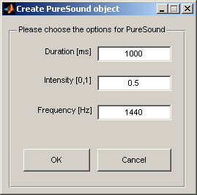
Duration [ms] – the duration of the sound in milliseconds
Intensity [0, 1] – the volume of the sound (0 – silent, 1 – full volume)
Frequency [Hz] – the sound frequency in Hertz

- Accord Sound – defines the sound that consists of the number of one tone sounds
Generated according to 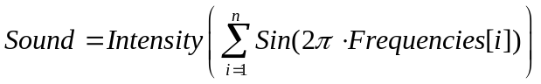
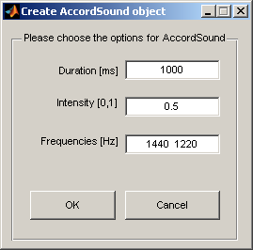
Duration [ms] – the duration of the sound in milliseconds
Intensity [0, 1] – the volume of the sound (0 – silent, 1 – full volume)
Frequencies [Hz] – the accord frequencies in Hertz. Enter the frequency you wish to modify first.

- Noise Sound – the white noise or spectral filtered (from Start Frequency to Stop Frequency) noise sound.
Generated according to 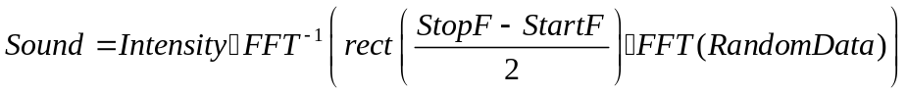
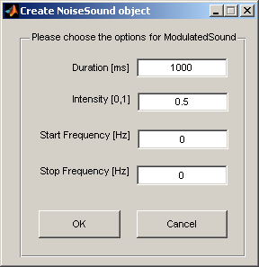
Duration [ms] – the duration of the sound in milliseconds
Intensity [0, 1] – the volume of the sound (0 – silent, 1 – full volume)
Start Frequency [Hz] – the start frequency of the noise sound in Hertz. Enter zero if you wish to define a sound as white noise
Stop Frequency [Hz] – the stop frequency of the noise sound in Hertz. Enter zero if you wish to define a sound as white noise

- Modulated Sound – the frequency/amplitude modulated sound.
Amplitude modulation:
Frequency modulation:
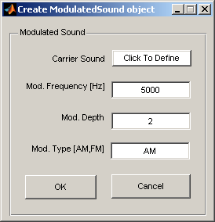
Carrier Sound – the carrier sound
Mod. Frequency [Hz] – the modulation frequency in Hertz
Mod. Depth – modulation depth
Mod. Type [AM, FM] – modulation type, could be either AM (amplitude modulation) or FM (frequency modulation)

- Gap Sound – sound with a silent gap between two sounds
Generated according to 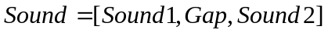
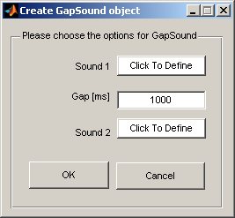
Sound1 – the first sound
Gap [ms] – the gap between Sound1 and Sound2 in milliseconds
Sound2 – the second sound

Run Tool: Executing the PSS Test
In order to execute the PSS Test, the test has to be created by TestTool and saved as a *.test file.
Pressing the Run Tool button will prompt the user to select the PSS Test he wishes to launch:
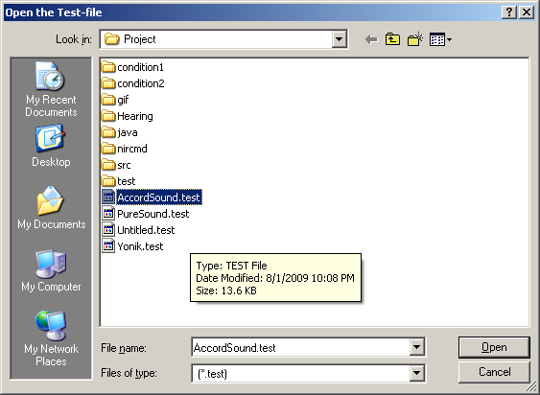
The second prompt will ask to specify the *.results file where the test results will be saved immediately after completing the test:
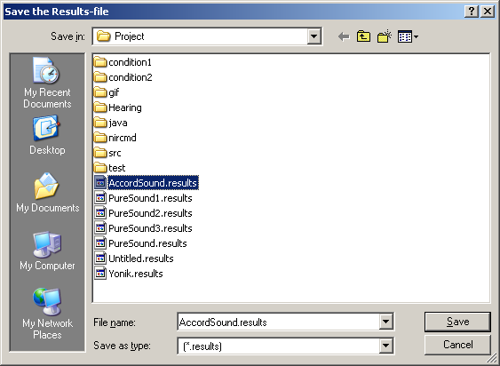
Please pay attention that the data saved will be in Matlab binary (mat) format after the Test completion, to insure robustness intermediate results will be saved after each PSS Test trial in human readable text form under the same name as the user specified for mat file with the addition of ‘.txt’ file extension. For example saving the data into mat file named ‘AccordSound.results’ will produce text file ‘AccordSound.results.txt’.

The PSS Test starts with displaying PSS Test GUI (“mouse” theme)
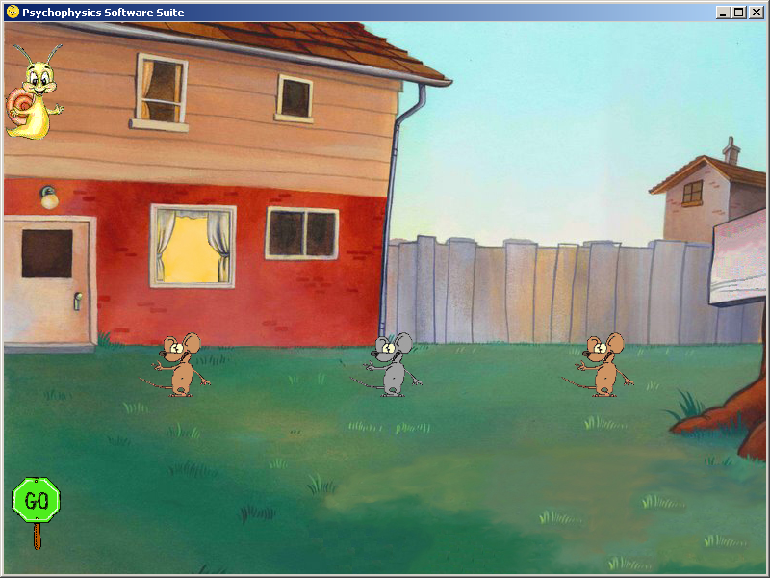
Snail moves right as PSS Test is progressing forward
Active (clickable) mouse
Passive (unclickable) mouse
Go/Stop Button
Active (clickable) mouse
The snail displayed above is used as a progress bar to indicate as the PSS Test is progressing.
Active (clickable) mouse represents A or B trial sound, passive (unclickable) mouse represents X sound (see Block parameters for more detailed explanation).
Go/Stop Button enables the user to start or stop the PSS Test. It also useful when user misses the test tones due to some reason and is willing to repeat it: pressing Stop and consequently Go will repeat the last trial sound sequence.
Please pay attention that PSS Test is started in stopped mode, so Go button has to be pressed to start the first block of the test; all consequent blocks will be launched in running mode, so there is no need in pressing Go button.

Analysis Tool: Displaying the PSS Test results
Pressing the Analysis button will prompt the user to select a *.result file:
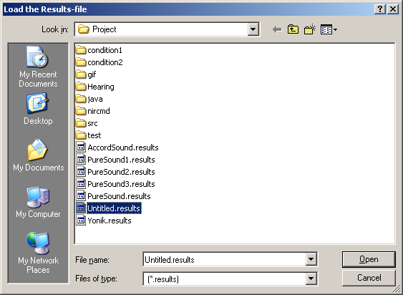
Immediate after opening *.results file, the tool will display the first block data:
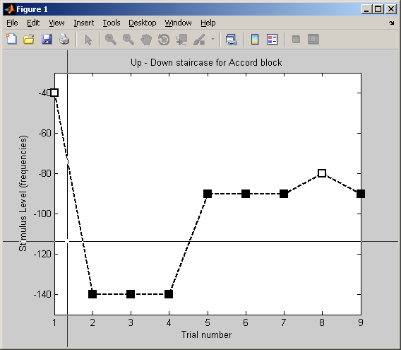
Prompting the user to select the trials that user is willing to include in standard deviation and mean calculation.

Let’s say, we’re interested in trials 2 to 9, so by clicking on the corresponding trials we will get:
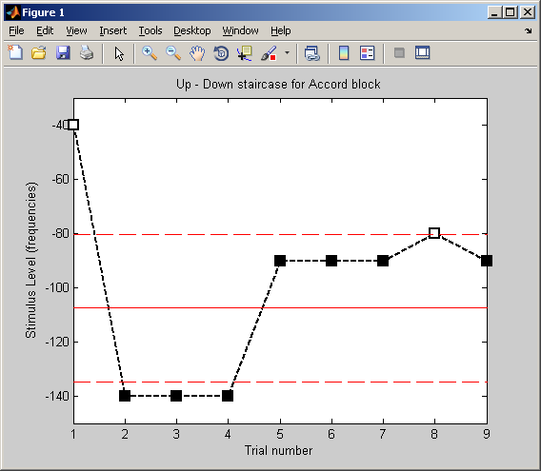
Where the red solid line represents the mean value and the dotted lines represent upper and lower bounds of standard deviation. After processing the first block, consequent blocks prompts will appear.

